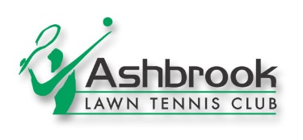

Ashbrook Tennis Club – Child Protection Policy

Code of Conduct for Parents

Ashbrook Tennis Club believes that as parents you should:

- Be a role model for your child and maintain the highest standards of conduct when interacting with young people, other parents, officials and organisers.

- Always behave responsibly and do not seek to unfairly affect a player or the outcome of the game.

- Never intentionally expose any young participant to embarrassment or disparagement by the use of flippant or sarcastic remarks.

- Always recognise the value and importance of the officials and volunteers who provide sporting and recreational opportunities for your child. Do not publicly question the judgement or honesty of referees, umpires, coaches or organisers. Respect convenors, professionals, coaches, referees, umpires, organisers and other players. Parents are welcome to attend events and coaching sessions but should not interfere with the coach or organiser while working with the player.

- Encourage your child to play by the rules of tennis. Teach your child that honest endeavour is as important as winning and do all you can to encourage good sportsmanship.

- Set a good example by applauding good play on all sides. Encourage mutual respect for other junior members, teammates and opponents.

- Support all efforts to remove abusive behaviour and bullying behaviour in all its forms. Please refer to bullying policy within the club’s Child Protection Policy.

Parents Code of Conduct:

- I will respect the rules and procedures set down by Irish Sports Council Code of Ethics and Good Practice for Children’s Sport.

- I will respect my child’s teammates and leaders as well as players, parents and coaches from opposing teams. I will encourage my child to treat other participants, professionals, coaches, convenors, selectors and managers with respect.

- I will give encouragement and applaud only positive accomplishments whether from my child, his/her teammates, their opponents or the officials.

- I will respect my child’s leader(s) and support his/her efforts.

- I will respect the officials and their authority during sessions and events whether within the club or outside.

- I will never demonstrate threatening or abusive behaviour or use foul language.

The undertaking to abide by and support the club’s Child Protection Policy given by the parent/legal guardian is deemed to be their agreement to abide by this code of conduct.

